2nd:


Hi everyone.
Today I want to introduce you to cursor AI, an innovative tool that is revolutionizing the way we write codes as artificial intelligence continues to shape our world.
Cursor AI emerges as a powerful assistant designed to enhance productivity, simplify coding tasks, and support developers in creating more efficient software solutions.

So what exactly is cursor AI?

It is an AI powered code editor that integrates seamlessly with your development workflow.

Unlike traditional code editors, cursor AI provides intelligent code suggestions, automatic bug detection, and even generates complex code structures based on natural language prompts.

This means developers can spend less time debugging and more time focusing on building high quality applications.

One of the most remarkable features of cursor AI is its ability to understand context.
Access.

For example, if you are working on a Python project and need a function to process data, you can simply describe what you want and cursor. will generate a vast structures and efficient function for you.

It also helps in refactoring code, making it cleaner and more maintainable.
Moreover, cursor I is an excellent learning tool.
If you are a beginner, you can use it to understand coding principles, get suggestions, and even learn best practices from AI generated recommendations.
It's like having a personal coding mentor available 24 by seven.

In summary, cursor AI is transforming software development by making coding smarter and more efficient.

Whether you are a beginner or experienced developer, this tool can significantly boost your productivity and coding experience.

Alright my dear friends.
So now let's move on to our next lesson and learn the basics of cursor.
I better.

3rd:

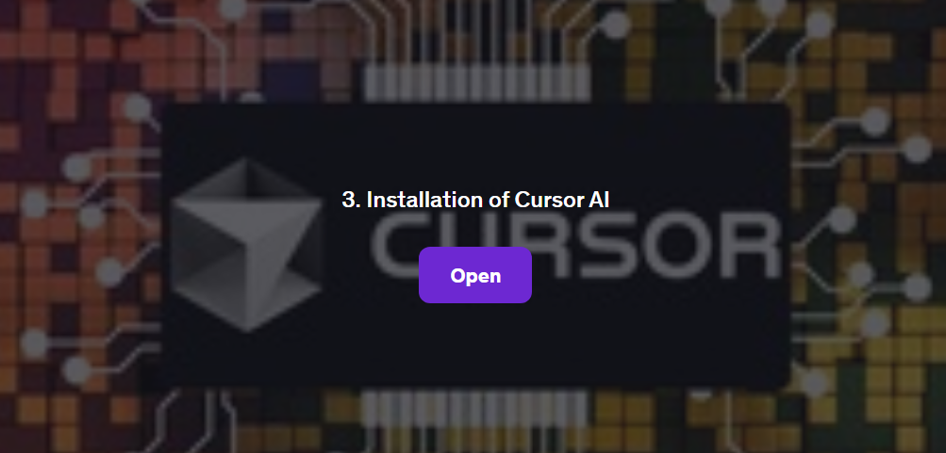

Installation of Cursor AI

How to Install and Set Up Cursor AI

Introduction
Cursor AI is an AI-powered coding assistant designed to improve developer productivity. This guide will walk you through installing and setting up Cursor AI on your system.

Prerequisites

Before installing Cursor AI, ensure you have the following:

- A compatible operating system (Windows, macOS, or Linux)
- Node.js installed (recommended latest LTS version)
- Git installed
- An internet connection

Installation Steps

1. Download Cursor AI
Go to the official Cursor AI website and download the appropriate version for your operating system.

2. Install Cursor AI
For different OS, follow the installation steps below:

Windows:

- Open the downloaded .exe file.
- Follow the on-screen instructions to complete the installation.

macOS:

- Open the downloaded .dmg file.
- Drag and drop Cursor AI into the Applications folder.

Linux:

- Open the terminal.
- Run the following command:

  - sudo dpkg -i cursor-ai.deb # For Debian-based systems
  - sudo rpm -i cursor-ai.rpm # For Red Hat-based systems

- Verify Installation

After installation, open a terminal or command prompt and run:

- cursor –version

If Cursor AI is installed correctly, you should see the version number.

4. Set Up Cursor AI

- Open Cursor AI.
- Sign in or create an account.
- Follow the setup wizard to configure your preferences.
- Integrate Cursor AI with your preferred code editor (VS Code, JetBrains, etc.).

5. Test Cursor AI

To ensure everything works, open your code editor and start using Cursor AI for code suggestions and completions.

Conclusion

Congratulations! You have successfully installed and set up Cursor AI. Now, you can enhance your coding experience with AI-powered assistance. Happy coding!

